**DAILY ONLINE ACTIVITIES SUMMARY**

|  |  |  |  |  |  |  |  |  |
| --- | --- | --- | --- | --- | --- | --- | --- | --- |
| **Date:** | 10/06/2020 | | | | | **Name:** | RIYA CP | |
| **Sem & Sec** | IV Sem & B section | | | | | **USN:** | 4AL18CS070 | |
| **Online Test Summary** | | | | | | | | |
| **Subject** | | Object Oriented Concepts | | | | | | |
| **Max. Marks** | | 30 | | **Score** | | | 12 | |
| **Certification Course Summary** | | | | | | | | |
| **Course** | Java Programming | | | | | | | |
| **Certificate Provider** | | | Greatlearning academy | | **Duration** | | | 5.5 hours |
| **Coding Challenges** | | | | | | | | |
| **Problem Statement1:** Write a C Program to print the sum of boundary elements of a matrix.  **Problem Statement2:**Java Program to find the longest repeating sequence in a string  string:acbdfghybdf | | | | | | | | |
| **Status: Executed** | | | | | | | | |
| **Uploaded the report in Github** | | | | | YES | | | |
| **If yes Repository name** | | | | | lockdown-coding | | | |
| **Uploaded the report in slack** | | | | | YES | | | |

**Online Test Summary**:18CS45 test was scheduled from 9:15am t0 9:40am.The portion for the IA was 3rd and 4th module there were 15 questions and the time assigned was 30 minutes the questions were to predict the output of the given program.

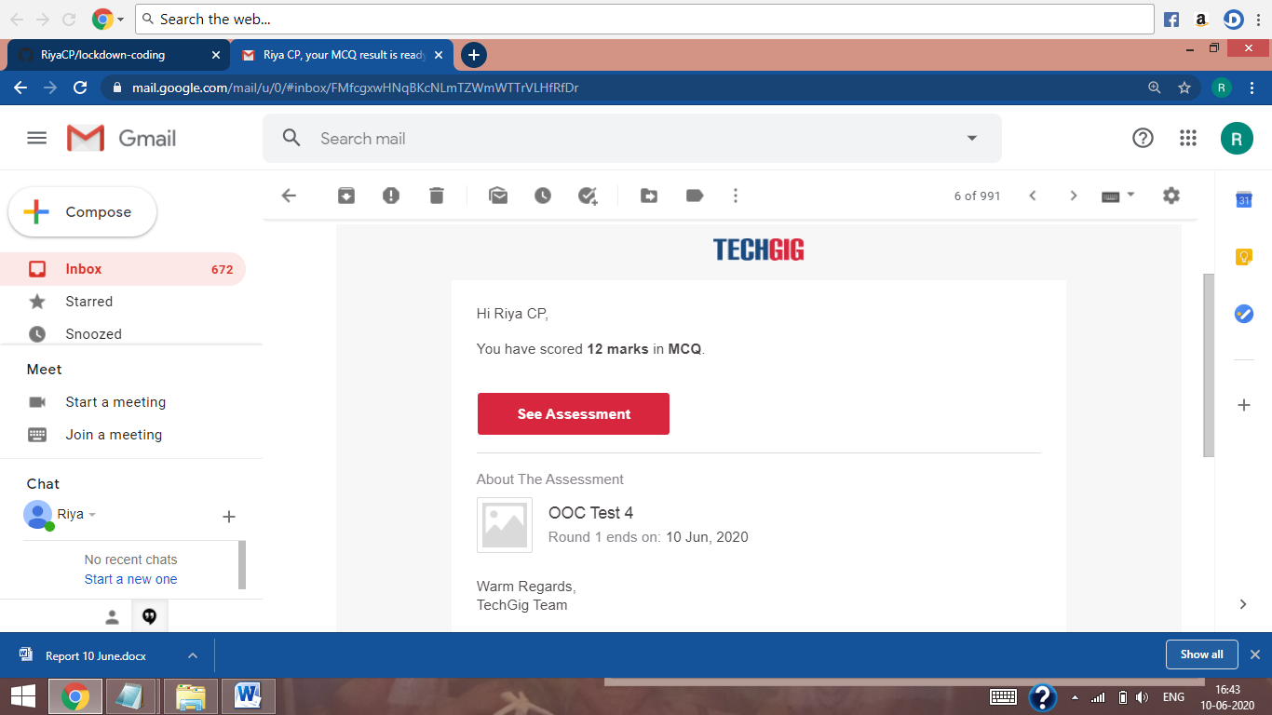

The above snap shot is the completion of the test and the marks allotted.

**Online Certification Course Summary:** In today’s session I have learnt about arrays in java, Functions in java, Inheritance in java and also object oriented programming in java and completed the course by attempting the quiz.

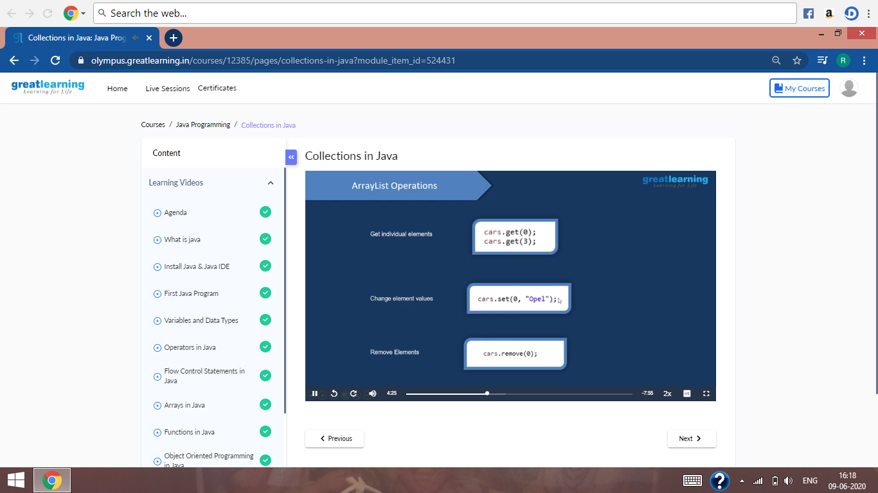

These are the snap shots of today’s sessions.

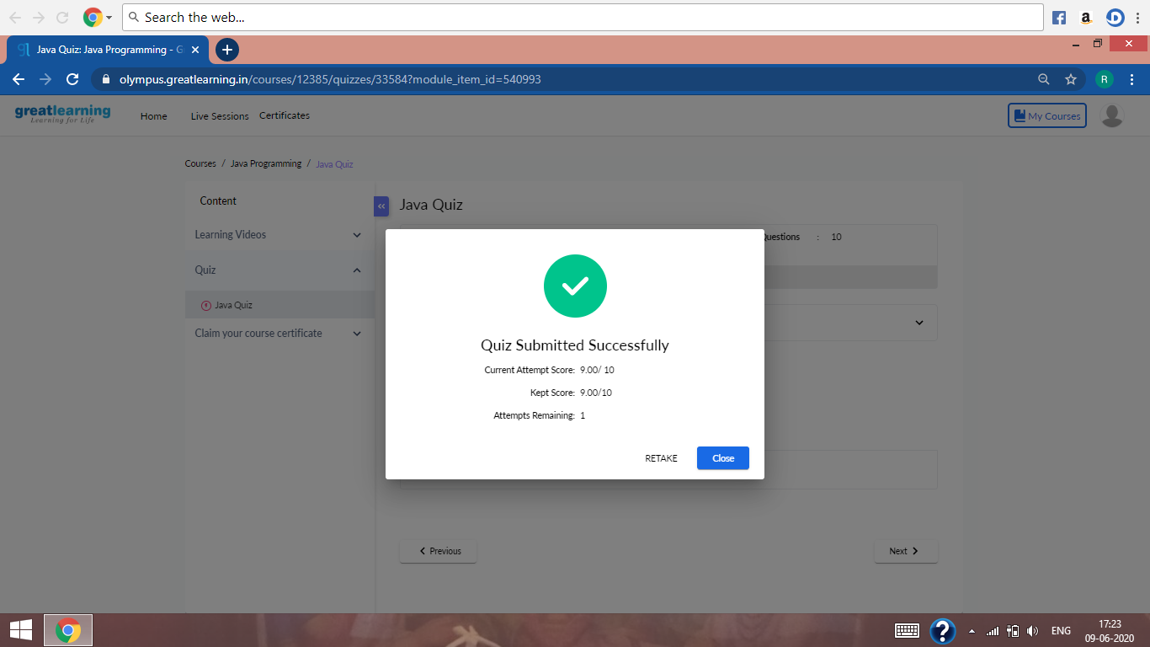

This is the snap shot of the quiz attempted.

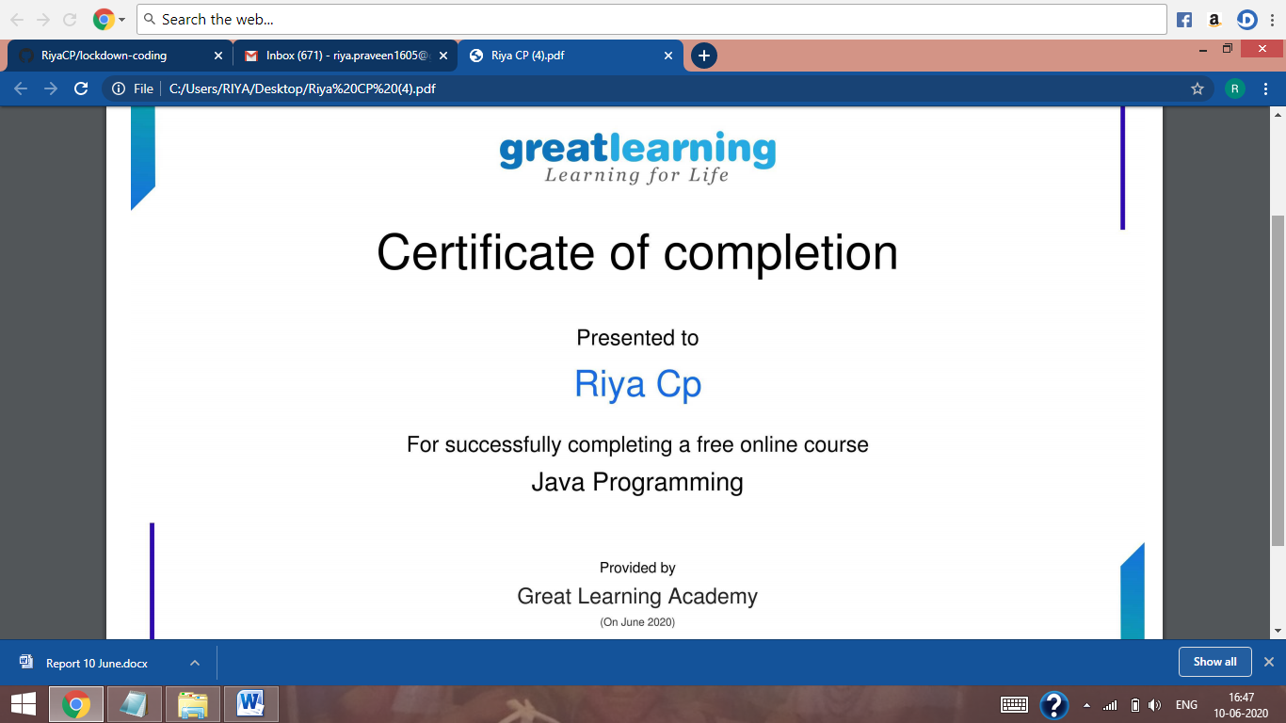

This is the snap shot of the completion certificate after attending the quiz successfully.

**Online Coding Summary:** Today I had received one program from prof. Reena Lobo CSE Dept. and prof.Venkatesh CSE Dept. The program is mentioned above in the coding challenges (pg.01). I have also uploaded it to my Github repository.

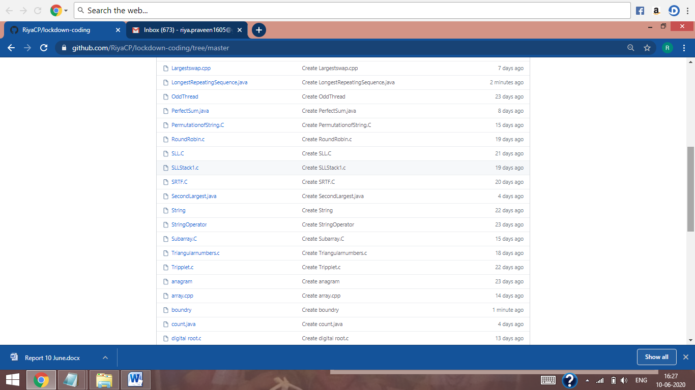

It is the snap shot of my repository were I have uploaded the code. File name is LongestRepeatingSequence.java and boundry.c